
Lab Assignment/Task Report
Only for course Teacher
 |  | Needs Improvement | Developing | Sufficient | Above Average | Total Mark
Allocate mark & Percentage |  | 25% | 50% | 75% | 100%
Clarity
Content Quality
Spelling & Grammar
Organization and Formatting
Total obtained mark
Comments

Semester: Fall 26
Student Name: Nadia Akther
Student ID: 26010157
Batch: 46th Section: B
Course Code: CSE124 Course Name: Object Oriented Programming
Course Teacher Name: Debabrata Mallick
Designation: Lecturer
Submission Date: 30 /07/2026
1. Hello and Name Printer
Write a Java program to print 'Hello' on screen and your name on a separate line.
Solution:
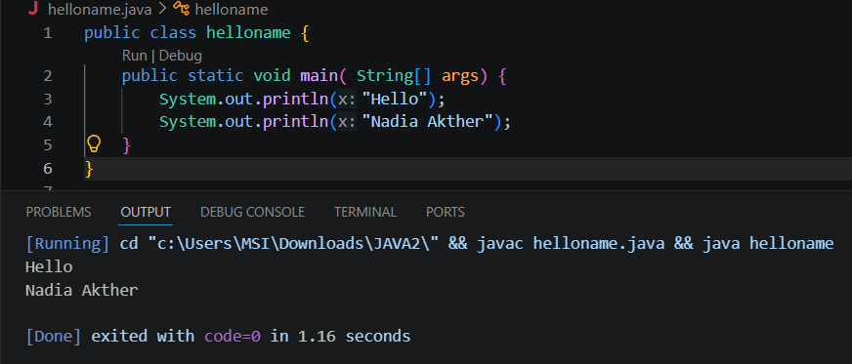
Explanation:
- Here I used ‘System.out.println(“ ”);’ to print “Hello” and my name “Nadia Akther”.
- Println breaks the line and that’s why Hello and my name are both in separate lines.

2. Sum of Two Numbers
Write a Java program to print the sum of two numbers.
Solution:
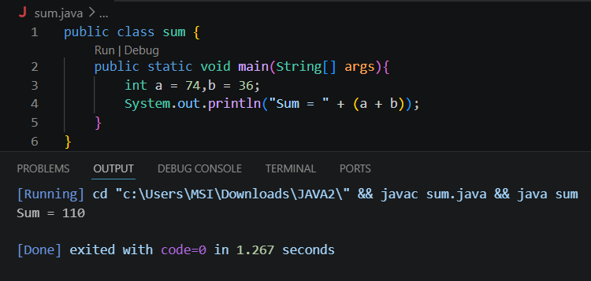
Explanation:
1.Here using the test data i did the sum of two numbers.
2. I used int a ,b to store the numbers then did sum directly in System.out.println(); where the sum had to be in another ‘()’ or the output would show something else (like 7436).

3. Division of Two Numbers
Write a Java program to divide two numbers and print them on the screen.
Solution:
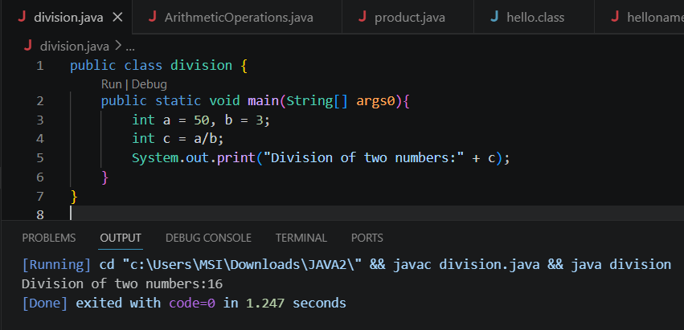
Explanation:
- Here using the test data I did the two numbers.
- I used int a ,b to store the numbers and used int to apply the division formula to get the division of two numbers.

4. Arithmetic Operations
Write a Java program to print the results of the following operations.
Solution:
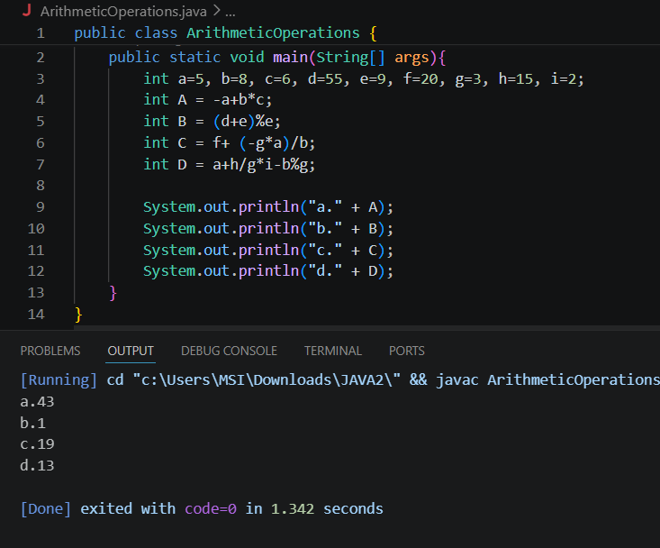
Explanation:
- Here I used the test data and stored them in different variables.
- Then i took those variables and applied arithmetic operators to solve each problems and they followed the order of operations BODMAS.
5. Product of Two Numbers
Write a Java program that takes two numbers as input and displays the product of two numbers.
Solution:
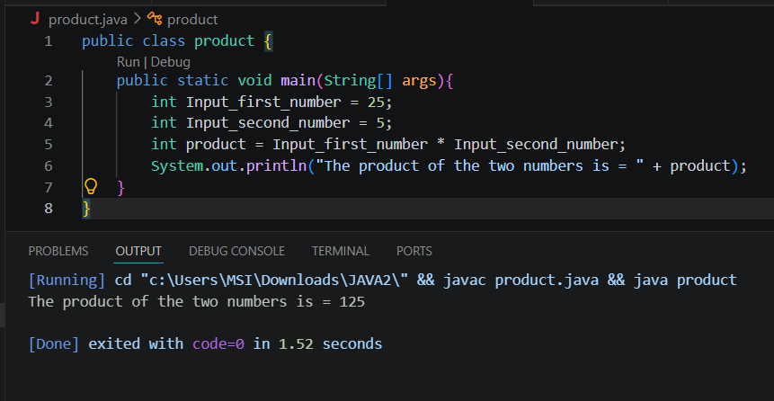
Explanation:
- Here I declared two numbers “Input first number: 25” and “Input second number: 5”. Then multiplied them using ‘*’.
- After inputting the multiplication formula i used “System.out.println()”; to print ‘The product of the two numbers’.

6. Basic Arithmetic Operations
Write a Java program to print the sum (addition), multiply, subtract, divide and remainder of two numbers.
Solution:
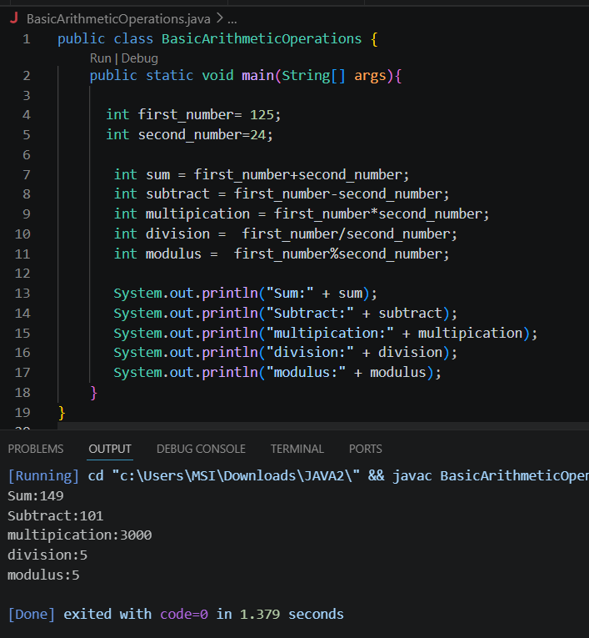
Explanation:
- Here I declared two numbers “Input first number: 125” and “Input second number: 24”.
- Then I did sum,substraction,multiplication,division and mod between those two numbers.

10. Formula Computation
Write a Java program to compute a specified formula.
Solution:
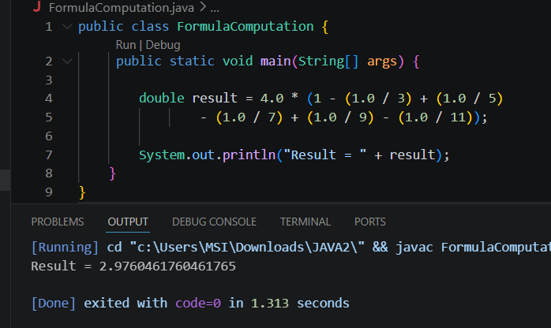
Explanation:
- Here i used double to calculate the equation with give the formula.
- By using double i can get accurate decimal precision for the result.

